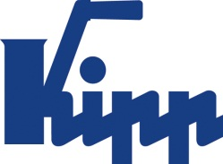

Press release Sulz am Neckar, Germany, February 2019

Company honoured again

KIPP convinces as Top Employer MSE 2019

HEINRICH KIPP WERK is delighted to be awarded the title 2019
Top Employer under mid-tier companies by FOCUS Business. The family company convinced for the second time in a row.

Every year FOCUS Business awards the "TOP Employer MSE" from amongst the mid-sized enterprises with 11 to 500 employees in Germany , Austria and Switzerland. The ranking is based on the ratings of kununu, from April 2018, Europe's largest employer rating portal.

To be included in the ranking, companies must have an overall rating of at least 3.5 stars (scaled from 1 to 5) and have collected at least 10 ratings. The result is made up of 13 different criteria regarding the company's well-being and career factor. The company is evaluated anonymously by the employees.

HEINRICH KIPP WERK has again achieved a very good placing in the machine and plant construction sector. Employees were particularly impressed by the modern working conditions, the varied tasks, the very good working ambience, the strong team spirit and the positive image.

"Parallel to this survey, we regularly conduct employee surveys and discuss the results in workshops. The satisfaction of our employees is our top priority. They lay the foundation for the success of the company and, for this reason it is our goal to be an attractive employer and to constantly develop ourselves further." , Nicolas Kipp Managing Director.

Characters including spaces:
Pre-head: 22 characters
Headline: 39 characters
Text: 1,378 characters
Total: 1,439 characters

HEINRICH KIPP WERK KG
Stefanie Beck, Marketing
Heubergstrasse 2
72172 Sulz am Neckar, Germany

Telephone: +49(0)7454 793-30
Email: stefanie.beck@kipp.com

Additional information and press photos
See www.kipp.com, Region: Germany, Category: News / Press area

Photos:

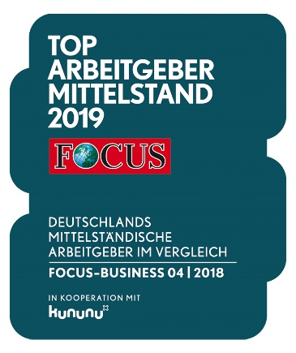  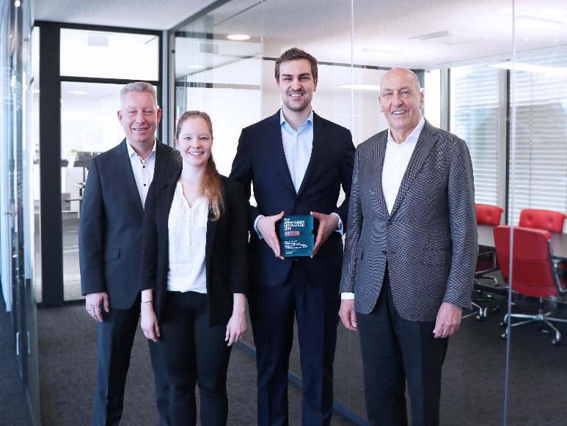  Top Employer under mid-tier companies 2019  LEFT to RIGHT:  Heinrich Kipp (Owner / Managing director)  Nicolas Kipp (Managing director)  Everlyn Wilhelm (Personnel officer)  Ralf Kauffer (Personnel manager)  Photo: KIPP | Image file:  KIPP_Top_Arbeitgeber_FOCUS_2019_Siegel.jpg  Image file:  KIPP_Top_Arbeitgeber_FOCUS_2019.jpg

Image copyright: Released for licence-free and royalty-free publication in speciality media.
Please cite the source and submit a reference.

